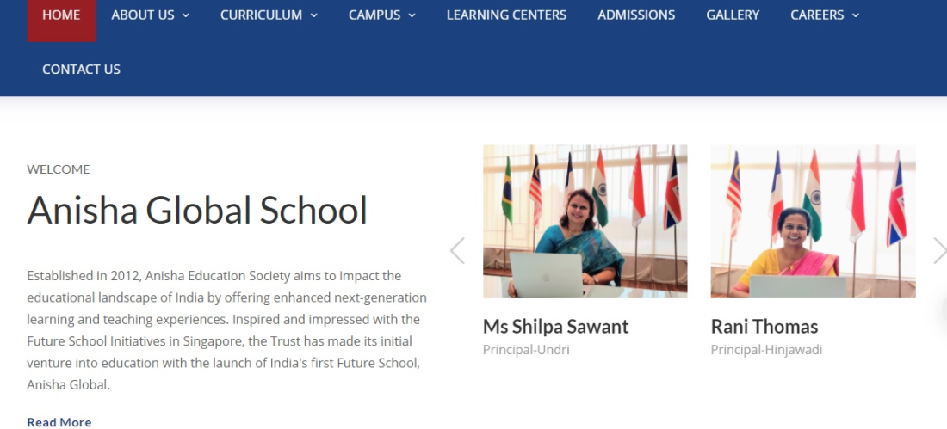

**Crimson**

**CORRECTIONS**

1. TABS: **CONTACT US** PLEASE MAKE IT MORE PROMINENT & Check how it looks if centered.
2. WELCOME IN BOLD PLEASE
3. NAME OF THE SCHOOL : **CRIMSON ANISHA GLOBAL SCHOOL**
4. NAME OF THE PRINCIPALS: Ms. Shilpa Sawant Ms. Rani Thomas

(Add full stop after Ms & add title Ms. for Rani Thomas)

1. Principal : Hinjewadi Campus (Correct the spelling & add Campus)

(Also, add the word Campus after Undri to read as Undri Campus)



1. Remove **upcoming events** all of the events (they are old)
2. Remove **Register Admissions** on Home page. Just keep it as Admissions
3. Remove **Get Newsletters**.
4. Write up to change as follows:  
   Established in 2012, Anisha Education Society aims to impact the

Educational landscape of India by offering enhanced next generation,

Futuristic learning and teaching experiences. Inspired and influenced

by the Future School Initiative in Singapore, the Trust made its initial

venture into education with the launch of India’s first Future School at

Hinjewadi, rapidly followed by a second Future school at Undri (NIBM Road)

1. Read more Anisha Eduation Trust (correct the spelling of Education)

Established in 2012, the aim of Anisha Education Trust ~~aims~~ is to affect the educational landscape of India by offering enhanced next-generation learning and teaching experiences. Inspired and ~~impressed~~ influenced by ~~with~~ the Future School Initiatives in Singapore, the Trust ~~has~~ made its initial venture into education with the launch of India's first Future School in Hinjewadi (Life Republic Township) in the year 2014.

The success of this school led ~~to~~ the trust ~~of~~ to establish~~ing~~ a second campus in Undri (NIBM Road) in the year 2016. Both schools are successful co-educational day schools and offer the CBSE and Cambridge International academic programmes from Kindergarten to Grade 12. Both campuses are spread over acres of large areas and offer a plethora of amenities to ensure holistic and all-round development of students.

1. MORE IN THIS SECTION

* [Anisha Education Trust](http://todlearning.com/anisha_school/trust.html)
* [School Leadership Team](http://todlearning.com/anisha_school/leadership.html)
* [Mission Statement](http://todlearning.com/anisha_school/mission.html)
* [Message From School Principal](http://todlearning.com/anisha_school/school_hinjewadi.html)s

1. Change sequence in ABOUT US & SCHOOL LEADERSHIP TEAM : ANKITA PATIL COMES FIRST FOLLOWED BY MS. FARZANA (like the e.g. given below)

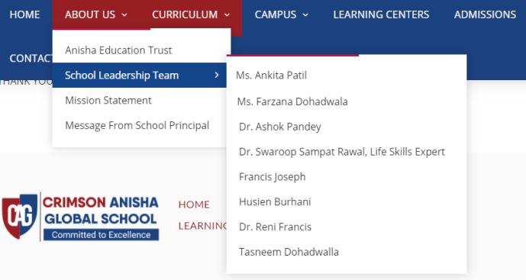

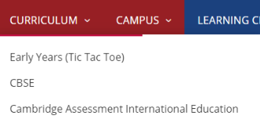

1. EARLY YEARS (TIC TAC TOE)

(**TIC-TAC TOE WRITE UP)**

At Crimson Anisha Global School we believe in our motto, which is “Committed to Excellence “

Right from the Early Years we are committed to support all developmental domains in our students to enhance their learning journey at our school.

Play is essential and we follow teaching strategies to make learning joyful and fulfilling and to foster children’s curiosity and enjoyment in exploring the world. Our strategies are a nice blend of Te-wharkiki, Reggio Emellia and Gijubhai Bhadeka’s methods.

Early childhood education and care begins when our students walk through the school gate. Our curriculum is concept driven yet child centred to ignite their imagination and help them become innovators and problem solvers with the right attitudes.

Our team of experienced educators and curriculum design experts have planned, age specific learning engagements for our young learners to encompass Social and Emotional Development, Language and Literacy, Creativity and the Arts, Physical and Motor Development and Mathematical and Logical Thinking.

Our aim is to use the foundation stage to nurture and tap the potential in each student at CAGS by emphasising on holistic development.

In the Online or physical classes, the planned learning outcomes are completed so in our spiral curriculum approach, each concept is taught from concrete to abstract. Quality is more important than quantity for us in our concept driven curriculum. Getting our students’ future ready and skilled to be lifelong learners is our commitment.



CURRICULUM CBSE

The main objective of CBSE is to provide stress free, child centered and holistic education to all children without compromising on quality. CBSE has effectively organised academic and training programmes and organised activities and supervise other agencies involved in the process.

It is important to adapt and innovate methods to achieve academic excellence in conformity with psychological, pedagogical and social principles. The schools are supported & encouraged to document the progress of students in a teacher and student friendly way.

CBSE has constantly strived to organise various capacity building and empowerment programmes to update the professional competency of teachers. Public examinations are conducted at the end of Class X and XII. Innovations in teaching learning, methodologies, ~~and~~ reforms in examinations and evaluation practices by devising students friendly and students centered paradigms.

Skill learning by adding job-oriented and job- linked inputs has been a big move by the CBSE. In order to execute its functions efficaciously, CBSE has set up its Regional Office in Pune.



**CURRICULUM**

**At both our campuses (Hinjewadi and ~~NIBM~~ Undri), CAGS is an authorised Cambridge International School.  
We offer the complete Cambridge Pathway (from Cambridge Primary up to AS/A Levels).**The Cambridge Pathway prepares students for life – helping them to develop an informed curiosity and lasting passion for learning.

**CAMPUS: Change from NIBM to Undri**

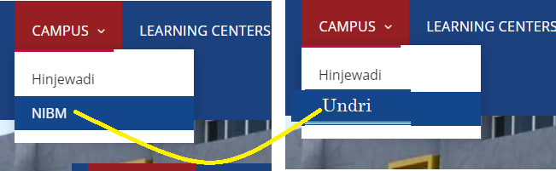



Bottom of Form

* [CONTACT US](http://todlearning.com/anisha_school/contact_us.html)

#### [Learning Centres - iFarm](http://todlearning.com/anisha_school/ifarm.html)

India is highly dependent on agriculture for her economic development. However, this important subject has largely been downplayed in the country's formal education system. At Anisha, farming is a part of our daily routine. The farms at Anisha are fondly known as I-farm by our students where they plant, grow and harvest variety of vegetables, fruits and exotic vegetables. The produce from I-farm is completely organic and is used for consumption by students in the form of food that they eat at school.

As a part of our program ‘One Child, One Tree’, each child who is at Anisha plants a tree and takes care of the same during his/her tenure in the school.

Students at the beginning of the secondary level begin to learn the basics of agriculture and subsequently the new agricultural technologies such as organic farming, Hydroculture, Fogponics and climate smart agricultural practices are introduced to them as they progress through higher secondary classes. They are equipped with skills on sustainable agriculture through hands-on activities in the schools' demonstration gardens.



#### [Learning Centres - Robotics, Electronics & AI](http://todlearning.com/anisha_school/ifarm.html)

Crimson Anisha Global School is proud to be a Microsoft Showcase School, which belongs to an elite community of around 2,200 selected schools across the globe. Both, the Hinj~~a~~ewadi and Undri ~~NIBM~~ Campus of CAGS, partners with Microsoft to provide personalized learning experience. Microsoft Showcase Schools explore the digital transformation of Microsoft technology into the classroom by integrating productivity tools such as Office 365, One Note, Skype, Sway, Azure, One Drive.

Crimson Anisha Global Schools have been awarded the Microsoft Showcase School designation in recognition for being ~~as~~ the best ~~of~~ amongst the best because of their demonstrated commitment to embracing technology to transform education and improve learning outcomes for students

###### ****Electronics****

Dr. Vijay Bhatkar Society for the Promotion of Innovations & Creative Excellence in Schools (SPICES) is an initiative taken by Crimson Anisha Global School. This has been named after Padma Bhushan Dr. Vijay Bhatkar, a thinker & thought leader, researcher & innovator, scientist & philosopher, policy architect & institution builder, he is one of the most acclaimed & celebrated scientists and IT leaders of India best known as the architect of PARAM supercomputers and bringing IT to masses through a wide range of path breaking initiatives.

**The objectives of this Cent~~e~~re at CAGS ~~Anisha~~ are:**  
To help India become an innovative and creative society.  
To build ~~the~~ knowledge transfer mechanisms and establish linkages between the Society and the schools across India and the world.  
To create an ecosystem comprising of experts with different specialized profiles and facilitate the knowledge & technology transfer.  
To disseminate information about innovations around the world and explore the possibility of absorption and diffusion.  
To develop competences of specialized profiles among the students.  
Support relevant research, analysis and exchange of data on the promotion of creative and innovative capacity through education and training.  
Develop ecosystems that favour creativity and innovation by promoting multi-level cooperation & multidisciplinary education~~s~~  
Identify ~~the~~ areas of ~~high~~ great future potential and help embed and develop ~~the~~ those latent skills.

###### ****Some projects undertaken by SPICES****

Students of Crimson Anisha Global School successfully launched ‘A’ NOTE, an Android based device ~~was Llaunched by Students of Crimson Anisha Global School an android-based devise. The device has been~~ made by Wyse Biometrics (The school's Research & Development Centre for Electronics). It is a 7-inch, hand-held device operating on a touch screen. It can be connected to legacy keyboard, mouse and can be hooked to your led TV over HDMI cable. It has an Ethernet port and additional facility of a WIFI network, giving many avenues to be connected with peers and teachers.

###### ****Eve - an E - cycle****

Eve - an E - cycle for girls has been designed in the school,~~. It is~~ a concept which ~~has~~ emerged from the creative minds of our students and which was brought into reality with the help of our teachers and mentors.

It is a cycle that functions on Solar Power. It has an in-built proximity sensor, a biometric based safety lock system and a health monitoring tablet device that which measures the heart rate, calories burnt, and it stores the routes of the cycle. It has a mobile charger and LED head and taillights.

###### ****Artificial Intelligence****

At Anisha CAGS, we take all efforts to make our student’s future ready and it is proven that Artificial Intelligence (AI) is being widely recognized to be the power that will fuel the future global digital economy. With ICT being our primary focus from the formative years, our ~~the~~ teachers are using various innovative ways to bring AI into the classrooms and it~~s~~ is influencing the way we teach and learn and is changing the landscape of future learning.

MIKO’s (Companion Robot) classroom at CAGS ~~Anisha~~ is a zone for students where learning becomes fun for students and they enjoy their school lessons like never before.

The students of ~~Anisha~~ CAGS have been a part of the voice sampling done for the creation of MIKO, the AI based companion robot and two students have completed their 6 months paid internship at Emotix where they were engaged in the research for the content development for mentally challenged ~~autistic~~ children.

#### 

#### [Learning Centres - Design, Animation & Game](http://todlearning.com/anisha_school/ifarm.html)

###### ****Design****

At Anisha CAGS ~~the~~ students are encouraged, to develop their artistic talents early from the primary years. The various programs and workshops held at school help them develop:   
The ability to perceive, understand and express concepts and feelings.   
The ability to record from direct observation and personal experience.   
The ability to communicate by using appropriate materials and techniques in a disciplined way.   
Experimentation, innovation and the use of intuition and imagination.   
Develop ~~C~~ritical and analytical faculties; the ability to identify, research and evaluate problems in a systematic way;   
Confidence, initiative and a sense of adventure and achievement.   
The acquisition of a relevant working vocabulary.   
An awareness and appreciation of the interdependence of Art and Design and the individual within cultural contexts.

###### ****Gamification of Learning****

We, at Anisha Global School adopt the gamification of learning as an educational approach to motivate the students to learn by using video game design and game elements in learning environments. We engage students with the Education Edition of Minecraft, which is an open world game that promotes creativity, collaboration, and problem solving in an immersive environment where the only limit is your imagination. Spatial thinking and pixel art in Minecraft create an excellent opportunity for students to work on mathematics and visual arts objectives in an engaging environment. Additionally, pixel art is a medium that is already engaging to students and one that allows educators to take their first steps with the game without being the expert.

It empowers an educator to create lessons with students and draw on their experiences. Minecraft world set up as a blank canvas for students to engage in creative expression.

#### 

#### [Learning Centres - Performing Arts](http://todlearning.com/anisha_school/ifarm.html)

###### ****Music****

Music is an integral element of the school calendar. Students learn ~~about the~~ classical, folk & devotional music. The students are exposed to Indian Classical Music as well as Western Music.

Music is an integral element of the school calendar as there has long been a correlation between musical training and academic success. Studies have proven that the comprehension of musical language can benefit a child's overall mental development. No matter what age the child might be, understanding the language of music~~al language~~ or learning to play an instrument can be challenging at times. However, those who learn music also learn to be disciplined in their training because that is the key to success.

~~The~~ S~~s~~tudents are trained by expert trainers who have several years of experience in their respective fields. The offerings of the musical instruments include; harmonium, Casio, tabla, dholak, drums, sitar, sarod, flute, violin and guitar.

#### [Learning Centres - Performing Arts](http://todlearning.com/anisha_school/ifarm.html)

###### ****Dance****

Dance is one of the highest forms of expression and an art that needs to be preserved and be taught from an early age. We believe that the joys and growth occurs when dance education is delivered in a disciplined environment with a systematic curriculum. Over time, young dancers discover that there will always be new steps to learn that build on one another. They are inspired to try new things once they master skills along the way. These benefits enhance learning at home, in school, and in other activities.

At Crimson Anisha Global School, we introduce ~~the~~ students to the Indian classical and western dance forms right from Std. 1 as rigorous training is required for a minimum of eight to nine years for a student to be able to capture the repertoire of a particular dance form.

#### [Learning Centres - Performing Arts](http://todlearning.com/anisha_school/ifarm.html)

###### ****Dramatics****

"The actions are performed completely by the qualities of Prakṛti . One who is deluded and bewildered by his ego thinks: 'I am the doer'"||27||

It has been well accomplished that dramatics ~~impact~~ affect positively on a student's physical, emotional, social and cognitive development. The students of Crimson Anisha Global have performed various dramas like: The Great Expectation, Hamlet, Jungle Book, Pot of Gold, Poos Ki Raat, Budhi Kaki to name a few.

**Every year the students showcase one drama and the entire project helps them to:** Develop understanding of drama through practical and theoretical study.   
Enable them to understand the role of actor, director and designer in creating a piece of theatre.   
Develop acting skills, both individually and in groups.   
Enable them to develop their skills in devising original drama.   
Help communicate feelings and ideas to an audience.   
Foster understanding of the performance process and enable candidates to evaluate the various stages of that process.   
Encourage enjoyment of drama.

The D~~d~~ramatics training/workshops at CAGS~~Anisha~~ ~~have~~ give~~n~~ the students a wonderful platform to enhance their self-confidence, imagination, empathy, cooperation, collaboration, concentration, oratory skills, presentation skills, communication skills and self- discipline.

#### 

#### [Learning Centres - Sports](http://todlearning.com/anisha_school/ifarm.html)

“A good hockey player plays where the puck is. A great Hockey player plays where the puck is going to be” – Wayne Gretzky.

CAGS ~~Anisha~~ encourages participation in sports that evidences the joys of participation, the pride of winning, the learning from losing, the passion, enthusiasm and the instinct to succeed. Well-trained coaches are in campus to train the students in the fundamentals & the strategies. Physical Fitness & exercises are emphasized throughout. The sports offerings include - cricket, hockey, soccer, basketball, handball, lawn tennis, table tennis, badminton, athletics, kho-kho, kabaddi and archery.

Crimson Anisha Global Schools have partnered with CTM Sports Development Co Pvt. Ltd., which is associated with a Brazil based sports company. CTM Sports is a team of professionals and sports lovers from the different countries – India, Brazil, Bolivia, Honduras, USA, who are passionate about using the power and influence of sports to impact young people with godly values and help shape a better future. With this partnership, we aim to provide a world-class football coaching experience to our students.

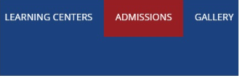

### Admissions

Thank You for your interest in Crimson Anisha Global School (CAGS). Admissions are NOW OPEN for the Academic Year 2021-22. Parents seeking admission for their child for the next year can click on the ADMISSION FORM icon located below to fill in the online enquiry form. Please fill in the form for the campus you seek to apply to Hinjewadi / Undri (NIBM Road).

We encourage you to explore our website to find out more about our school (both campuses), our leadership team, our mission and vision, our academic and extracurricular programs and other details.

You can also reach out to us on [**+917770017498**](tel:+917770017498)/[**+918007606843**](tel:+918007606843) (for the Hinjewadi campus) and  
[**+91 8087609333**](tel:+91%208087609333) for the Undri (NIBM Road) Campus to know more about our school and our admission process.

We believe in inclusive education. However, the decision to admit a student to CAGS is based on the availability of space at the appropriate grade level, the school's ability to meet each student's needs and the student's ability to fulfil our academic program requirements.

All prospective parents are requested to fill in the online inquiry form by clicking on the link given below.

Top of Form

**Admission Form ~~to have the following fields~~**

Name of ~~T~~the Student

Date of Birth

Grade/Standard currently studying in

Grade Seeking Admission to

Present School / Pre-School

Sibling in CAGS (YES / NO)

Father's Name

Mother's Name

Email address

Mobile Number

Message

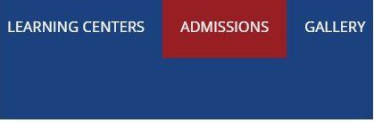

2016

2017

2018

2019

2020

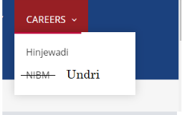

Bottom of Form